* CONTEXT TABLE

|  |  |
| --- | --- |
| **TOPICS** | **PAGE No.** |
| **Communication b/w 2 different networks using single router** | 2 |
| CASE 1 (direct connection using switches ) | 2-3 |
| CASE 2 (using single router for communication) | 3-5 |
|  |  |
| **Set –up the network topology using two routers on Packet tracer** | 5-7 |

In this experiment we will demonstrate how to connect two different networks using. Generally, two different networks(machines with different IP addresses) can not communicate with each other.

Below is the image of two different networks and a Router that is not connected to the switches of any network.

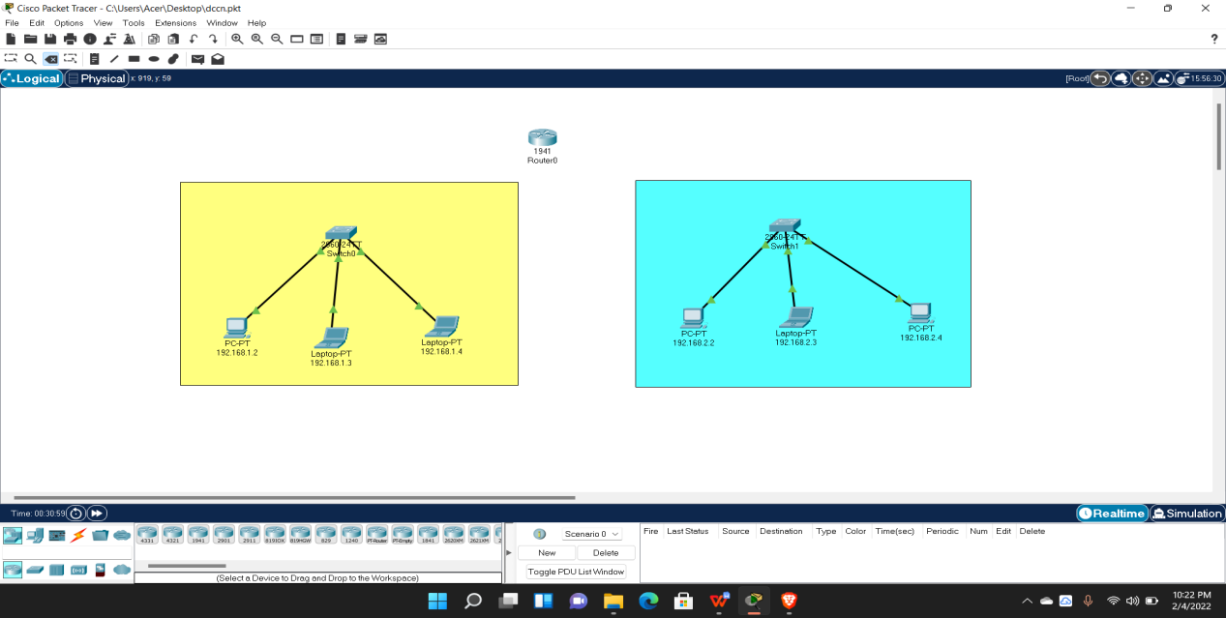

**CASE 1 :**

{trying to communicate between different network directly by connecting their switches}

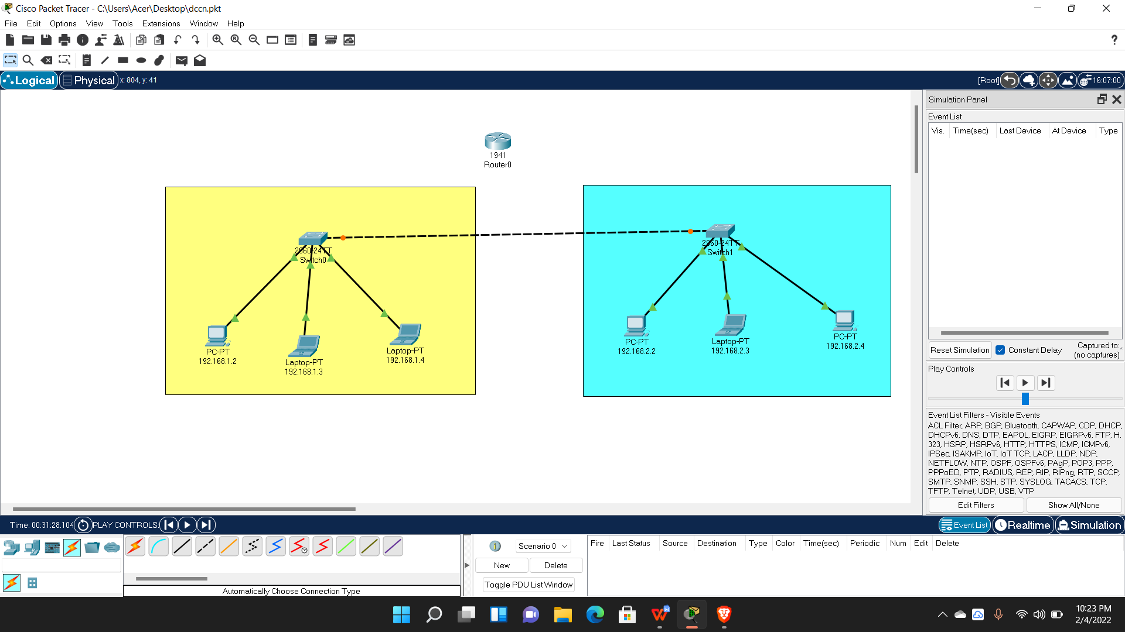

In above case, we can see two different networks. Here we tried to communicate between two different network directly. We tried to ping one of the computer in 2nd network with one of the computer of 1st network to observe/check if we will receive any replies or not.

**RESULT :**

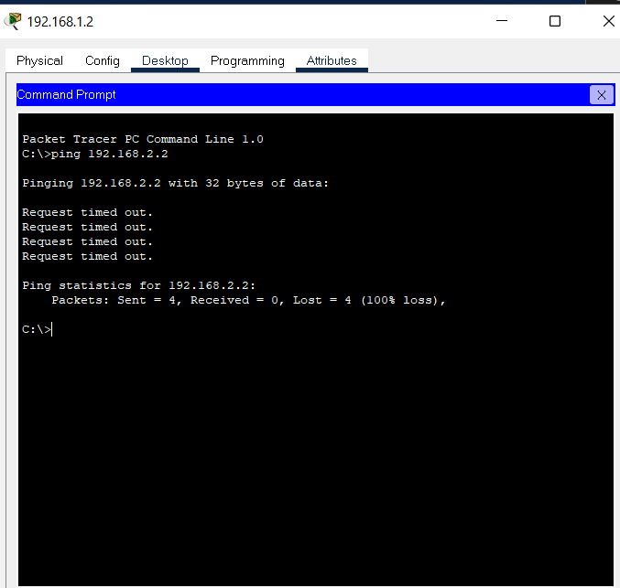

**CASE 2 : THE SOLUTION**

**{**Using Router to perform the communication**}**

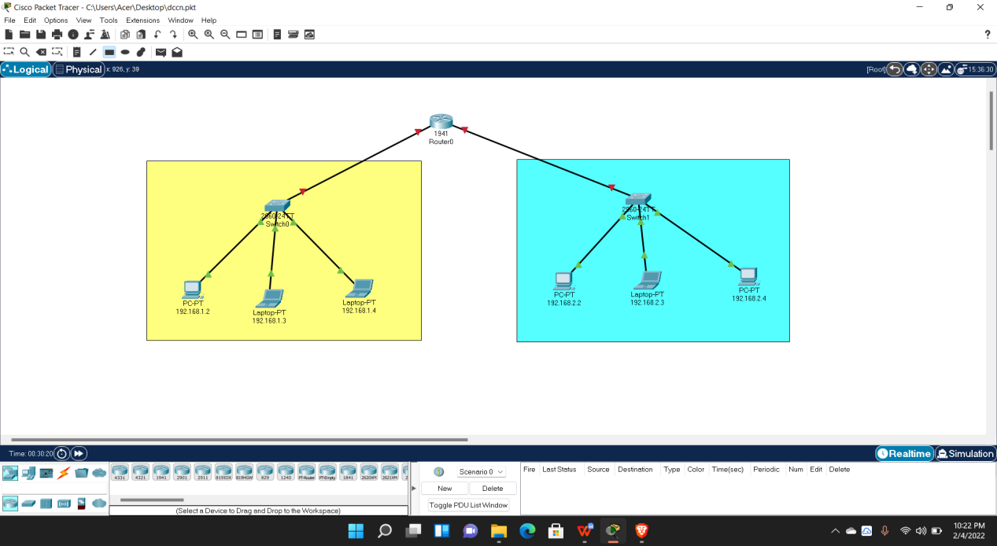

The solution is “Router”. By connecting switches of both distinct networks through Router, it is possible to perform communication between the computer that weren’t providing any reply earlier.

But first we have to perform some configuration in the ROUTER as shown below;

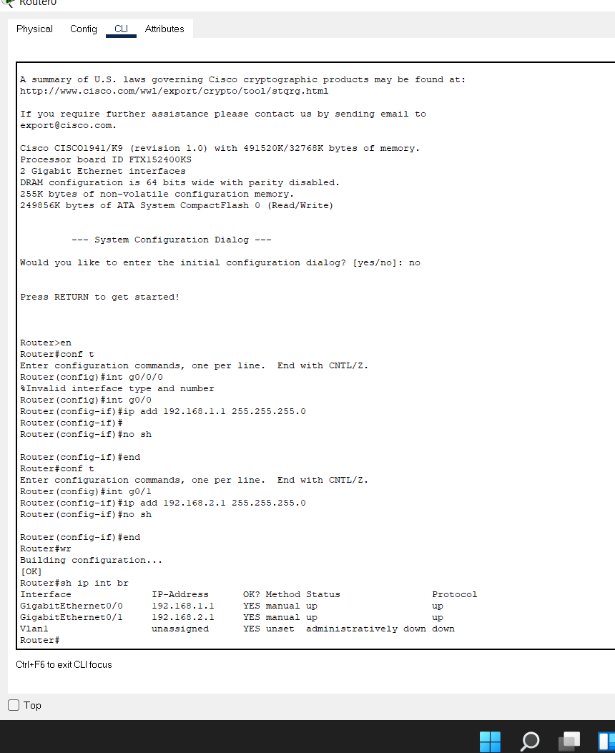

**RESULT :**

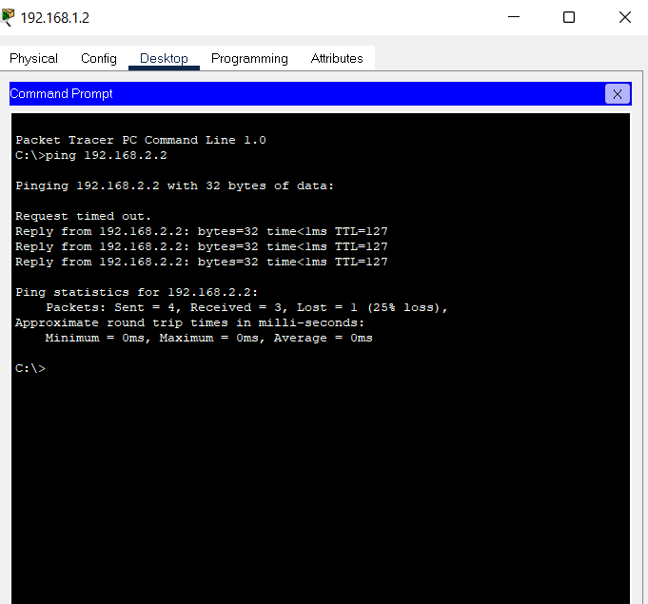

* The first few got time out because of ARP(i.e Address Resolution Protocol)

**FINAL IMAGE (**with this we proved occurrence of communication between two different networks using ROUTER**)**

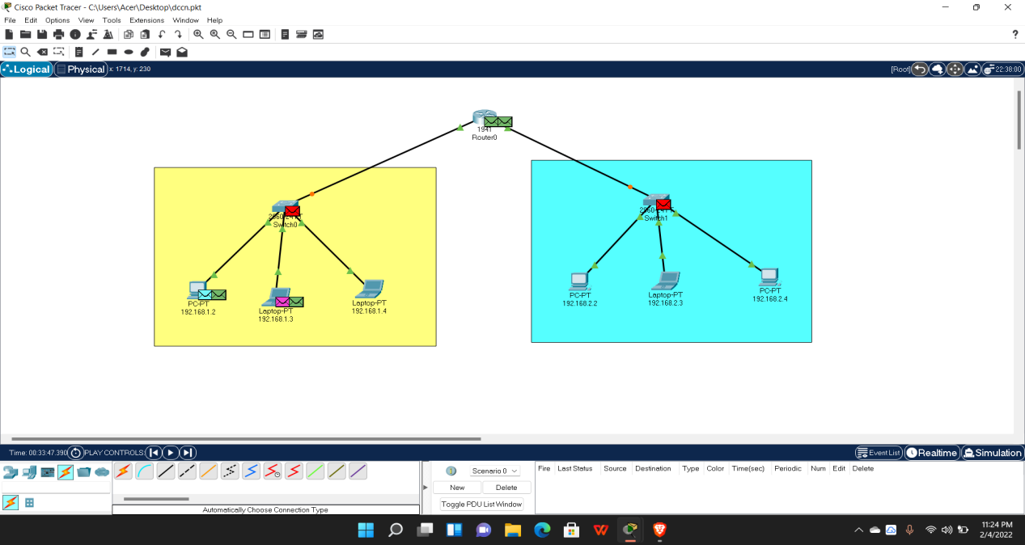

**EXPERIMENT 6**

**TOPIC :** Set–up the network topology using two routers on Packet tracer

The starting process is exactly same, we need to give ip address of computer(devices) of both networks. But the configuration part of router will be a little different in the case of using two router.

First Router Configuration;

en

config t

hostname R0

int g0/0

ip add 192.168.1.1 255.255.255.0

no sh

int g0/1

ip add 10.1.1.1 255.0.0.0

no sh

Second Router Configuration;

en

config t

hostname R1

int g0/1

ip add 192.168.1.2 255.255.255.0

no sh

int g0/0

ip add 10.1.1.2 255.0.0.0

no sh

Still communication will not occur because we haven’t provided “ip route”, the result will show ‘no replies’, with a reason Destination host unreachable

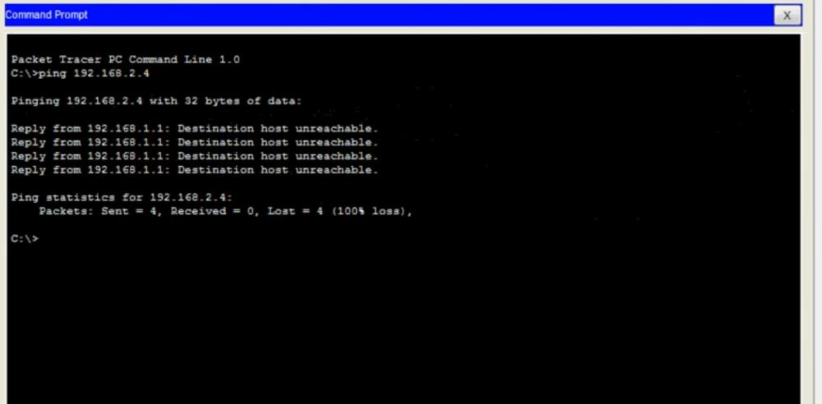

-- After Configuration we need to provide static ip route to both routers(inside router config) i.e;

ip route 192.168.2.0 255.255.255.0 10.1.1.2 (for first router, i.e in our case in R0)

ip route 192.168.1.0 255.255.255.0 10.1.1.1 (for second router, i.e in our case in R1)

Here; 192.168.2.0 and 192.168.1.0 are **ip add of the networks** with various devices

255.255.255.0 are the **Subnet Mask**

10.1.1.1 and 10.1.1.2 are the **ip assigned to each router**

**RESULT :**

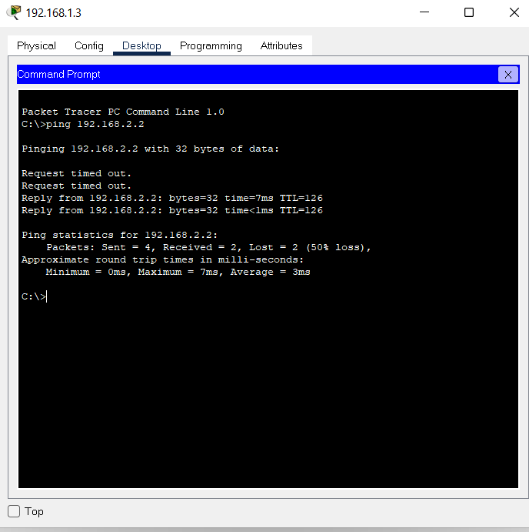

* The first few got time out because of ARP(i.e Address Resolution Protocol)

**FINAL IMAGE**

